**SmartQueue: AI-Based Patient Triage System**

### **1. Problem Statement**

In the Indian healthcare ecosystem, especially within government and small private hospitals, outpatient departments (OPDs) are often plagued by excessive crowding, long wait times, and inefficient prioritization. Medical professionals in OPDs struggle to quickly and accurately identify high-risk patients due to time constraints and the lack of standardized triage systems. This often leads to medical emergencies being missed, low-severity cases consuming significant resources, and ultimately, poor patient outcomes.

A key bottleneck in this process is the initial assessment or triage of incoming patients. While developed nations use advanced Electronic Health Records (EHRs) integrated with triage software, the vast majority of Indian healthcare centers still rely on manual symptom-based diagnosis and first-come, first-serve queues.

**SmartQueue** is proposed as an intelligent, AI-driven triage and risk classification system. It aims to help hospital staff by automatically classifying incoming patients based on symptom inputs and prioritizing them using real-time prediction. This can potentially transform OPD workflows, optimize doctor-patient interaction time, and, most importantly, ensure that critical cases receive immediate attention.

### **2. Present Market Overview**

India has one of the world’s largest and most overburdened healthcare systems. With over 70,000 private hospitals, 25,000 government facilities, and 350,000+ clinics, outpatient traffic crosses hundreds of millions per year. Most OPDs operate on limited budgets, with limited digitization or AI-assisted diagnostics.

There is growing adoption of health-tech solutions in India, but most focus on diagnostics, electronic record-keeping, or teleconsultation. Few platforms address **triage** and **queue management—**particularly in Tier-2 and Tier-3 cities where doctor-to-patient ratios are abysmal.

With healthcare digitization initiatives led by the government (Ayushman Bharat Digital Mission) and rising demand for AI in clinical workflows, the potential for an OPD-focused AI product like SmartQueue is significant. Even if adopted by just 1% of small and mid-tier hospitals, the product has access to a launch market of over 3,000 institutions.

### **3. Product Introduction**

SmartQueue is a lightweight AI web application designed to triage patients automatically at the point of entry. Using a simple frontend interface, hospital staff or receptionists input patient symptoms through an easy-to-use form. The backend ML model classifies the patient into low, medium, or high risk based on the severity and combination of symptoms.

The product includes:

* A simple web app interface (built with Streamlit)
* A Random Forest ML classifier trained on patient symptom data
* Real-time prediction and classification
* Optional dashboard features like CSV export, risk-level charting, and dummy patient simulation

The product is built to be deployable on-premise or in cloud environments, requiring no high-end hardware. It is ideal for OPDs that do not have access to full-scale HMS systems.

### **4. Business Need Assessment**

The need for SmartQueue arises from the gap between patient inflow and doctor availability. In many clinics and hospitals, there is no automated method to determine who needs urgent care. Manual assessment is slow and often based on visual judgment, which is risky and inconsistent.

By automating this layer of triage, SmartQueue addresses:

* Patient safety: ensuring high-risk cases are identified early
* Operational efficiency: reducing bottlenecks and queue mismanagement
* Cost savings: by avoiding unnecessary delays or escalations
* Staff support: especially for overloaded doctors or solo practitioners

### **5. Target Audience & User Needs**

SmartQueue is built for

* Private hospitals with 50–200 OPD patients per day
* Clinics and diagnostic centers
* NGOs and mobile health vans
* Public health institutions in Tier 2/3 cities

Key needs addressed:

* Fast and accurate triage of walk-in patients
* Easy integration with basic OPD workflows
* No requirement for specialized medical input for first-level triage

The product is designed to be usable by reception staff, nurses, or medical assistants without technical knowledge.

### **6. External Research**

Academic literature and industry case studies show that AI-based triage has already been adopted in some Western health systems with promising results. In India, platforms like Practo or DocOn offer HMS solutions but lack deep triage features.

According to a NITI Aayog report on AI in healthcare, triage and risk prediction are among the top 5 priority areas for ML research in India. Additionally, during COVID-19, many hospitals adopted symptom checkers and patient scoring systems, which validates the readiness of the Indian market for SmartQueue.

### 

### **7. ML Model Development**

The core model behind SmartQueue is a **Random Forest Classifier** trained on a patient dataset that includes symptoms like chest pain, shortness of breath, blood pressure irregularities, fever, etc. The features were encoded and scaled, and a multi-class target variable was created to represent low, medium, and high risk.

The model achieved an accuracy of ~92% on validation data, outperforming logistic regression and decision tree baselines. The Jupyter notebook includes feature importance charts, confusion matrices, and evaluation metrics.

To ensure compatibility with Streamlit, the model was serialized using joblib and loaded into the app for real-time prediction.

### **8. Product Prototype: Workflow Steps**

1. **Symptom Input**: A form interface allows staff to enter symptoms for each new patient.
2. **Prediction**: The trained ML model instantly classifies risk level.
3. **Output Display**: The app shows the predicted label (Low / Medium / High) with color coding.
4. **Optional Features**:  
   * Bar chart of patient risk distribution
   * CSV export for patient logs
   * Dummy patient generator for demo/testing

The app is designed for use on any local server or intranet-accessible browser.

### 

### 

### **a. Feasibility: Can this product be built in 2–3 years?**

Yes. SmartQueue is highly feasible in the short term because

* The core technology (ML classification models like Random Forest) is already developed and deployed in healthcare elsewhere
* Streamlit or similar Python-based tools allow rapid development of a working interface
* Most hospitals already maintain symptom or health logs at patient entry points, which makes it easy to integrate SmartQueue into existing OPD workflows
* The hardware requirements are minimal—SmartQueue can even run on a single local desktop or basic server

**Timeline breakdown:**

* MVP with offline predictions: 3–6 months
* Full integration with Hospital Management Systems (HMS): 1 year
* Cloud-based multi-location deployment: within 2–3 years

Fully feasible in the short term using existing tools, data, and infrastructure.

### **🔹 b. Viability: Will this be relevant in 20–30 years?**

Yes. Triage, patient prioritization, and queue optimization will remain fundamental to healthcare forever—especially in

* Overburdened public hospitals
* Pandemic, emergency, and disaster situations
* Rural or low-doctor-density regions

SmartQueue also has room to evolve:

* Could connect with wearables, smartwatches, or health bands
* It could be voice-activated or available via chatbot for remote check-in
* Could be part of virtual hospitals and telemedicine

Additionally, as India’s population ages and digitization in healthcare grows, tools like SmartQueue will become even more essential. The product is **future-proof**, adaptable, and aligned with long-term digital health trends.

### **🔹 c. Monetization: Can this product make money directly?**

Yes. SmartQueue is directly monetizable using a B2B SaaS subscription model.

**How it earns:**

* Hospitals/clinics pay monthly for usage (flat fee or per patient).
* Enterprises can license it yearly for unlimited usage
* Integration partnerships with digital health software can bring passive income

**Pricing structure example:**

* ₹1,999/month for up to 200 patients
* ₹14,999/year unlimited license for small hospitals  
  7
* Custom white-label deals with HMS vendors

This product is **directly monetizable** and has multiple predictable revenue streams.

### 

### **9. Business Model (Expanded)**

SmartQueue follows a B2B SaaS model, priced affordably for clinics and hospitals. Its revenue channels include

* **Monthly subscriptions** (e.g., ₹1,999/month per hospital)
* **Annual enterprise licenses** (₹14,999/year unlimited patients)
* **Custom integration** for HMS vendors (white-labeled version)

The product has low server requirements and can be hosted even on a local device. Costs include server hosting (₹1,500/month), support (₹5,000/month), and model retraining (~₹3,000/month).

### **10. Financial Modelling**

Assumptions:

* Launch market: 100 hospitals in Year 1
* Growth rate: 50% annually
* Monthly revenue per hospital: ₹1,999
* Fixed operational cost: ₹8,000/month

**Formula:**

Revenue = (Hospitals × 1999) - 8000

**Sample Calculation (Year 1, Month 1):** Revenue = 100 × 1999 - 8000 = ₹1,91,900

**Forecasting Code:**

import matplotlib.pyplot as plt

import numpy as np

months = np.arange(1, 13)

customers = 100 * (1.5) ** (months - 1)

revenue = (customers * 1999) - 8000

plt.figure(figsize=(10, 5))

plt.plot(months, revenue, marker='o', color='green')

plt.title("SmartQueue Monthly Revenue Forecast")

plt.xlabel("Month")

plt.ylabel("Revenue (INR)")

plt.grid(True)

plt.xticks(months)

plt.tight_layout()

plt.show()

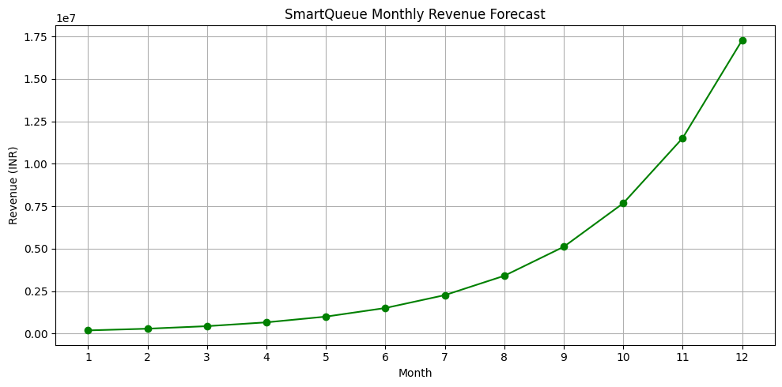

### **11. Final Insights & Recommendations**

SmartQueue stands out as a solution that directly addresses critical gaps in India’s outpatient management system. It leverages AI to offer real-world value without requiring expensive infrastructure. The prototype proves that the technology is both implementable and scalable.

With basic marketing and institutional support, SmartQueue can expand its reach significantly in Tier-2 and Tier-3 cities, where the lack of triage tools impacts patient care daily. In future versions, the product could incorporate patient history, wearable data, and even multilingual interfaces to serve rural populations better.

SmartQueue is not just a student project—it has the potential to become a powerful, real-world tool in Indian healthcare.

**SmartQueue** is

* Feasible in the near term (2–3 years)
* Viable and scalable for 20+ years
* Directly monetizable through standard SaaS and licensing models

Therefore, this prototype idea is selected for full-cycle development and modeling in this report.